**Name : Hemalatha Karumuri**

**Date : 13/12/23**

1)Control structures: simple if statements

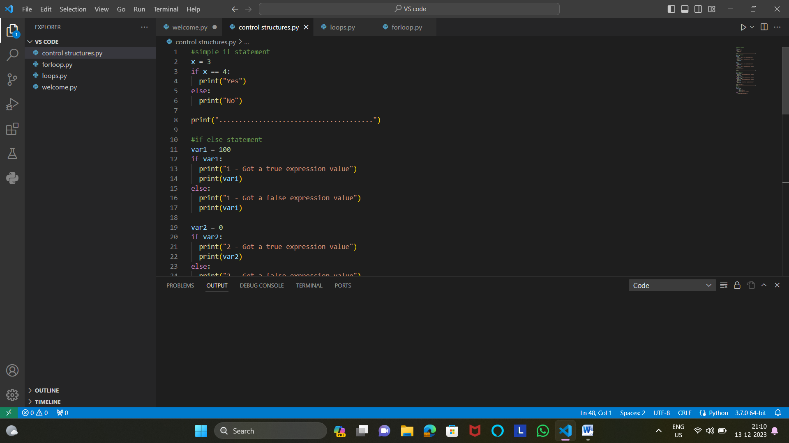

2)elif statements

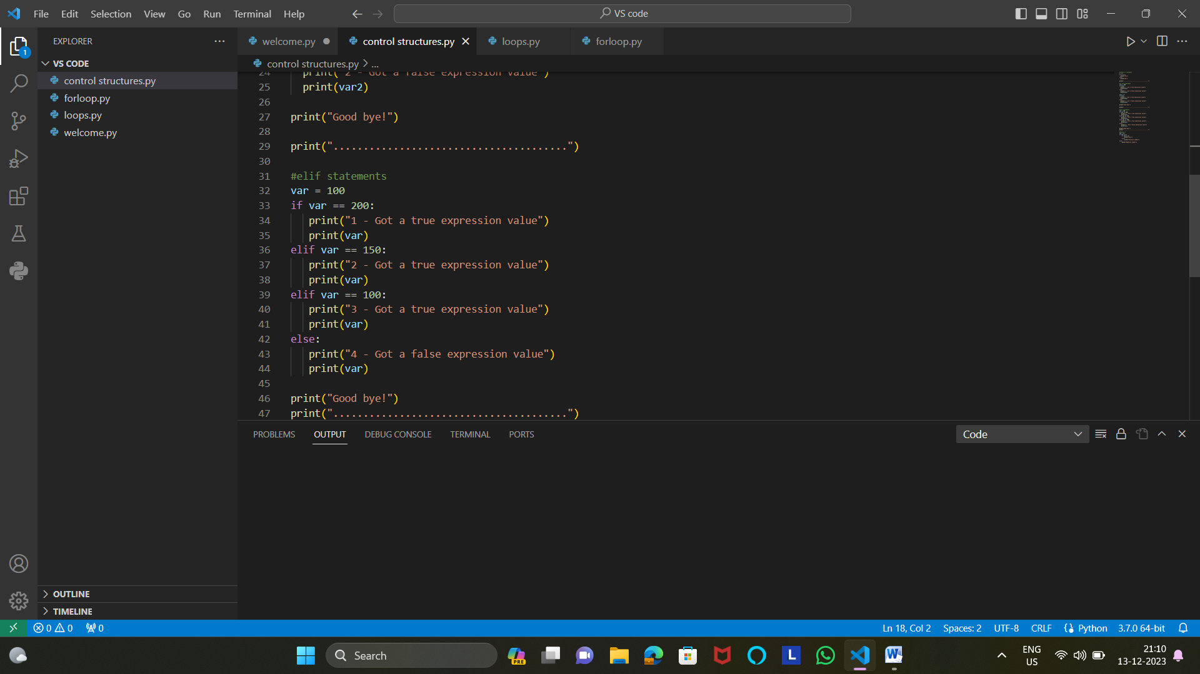

3)Nested if statements

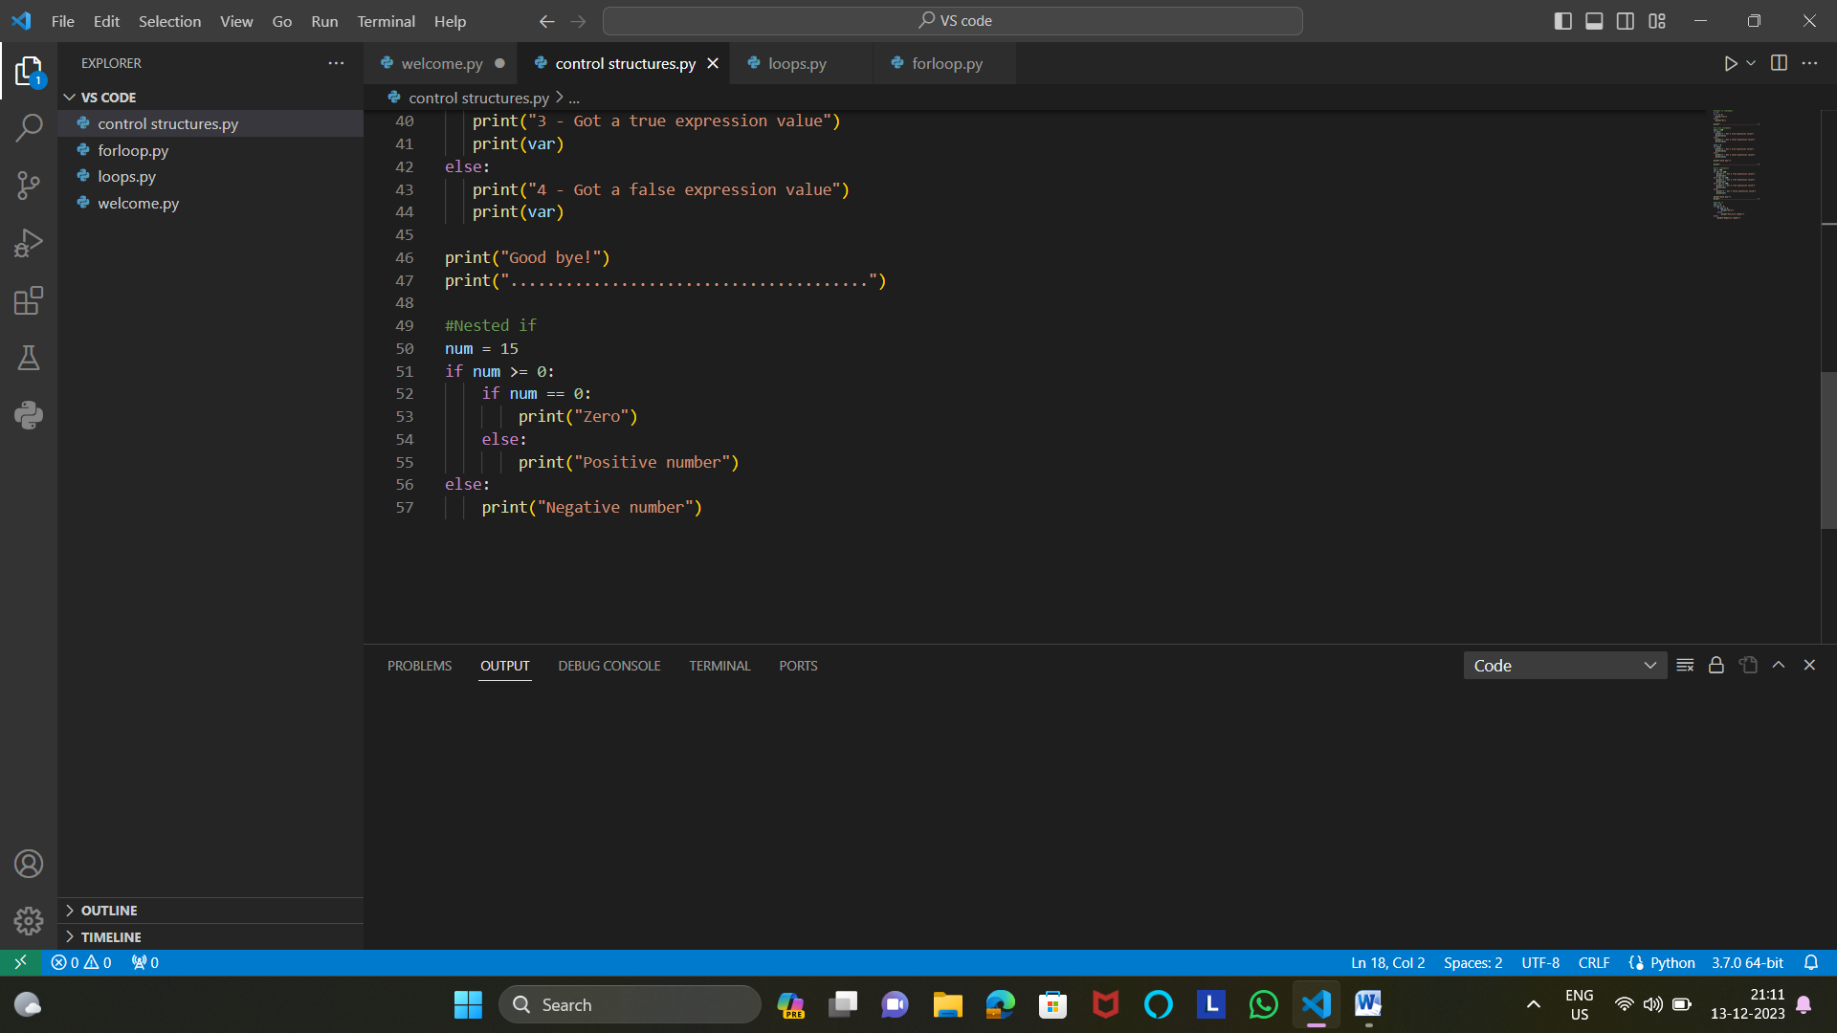

4)while loop

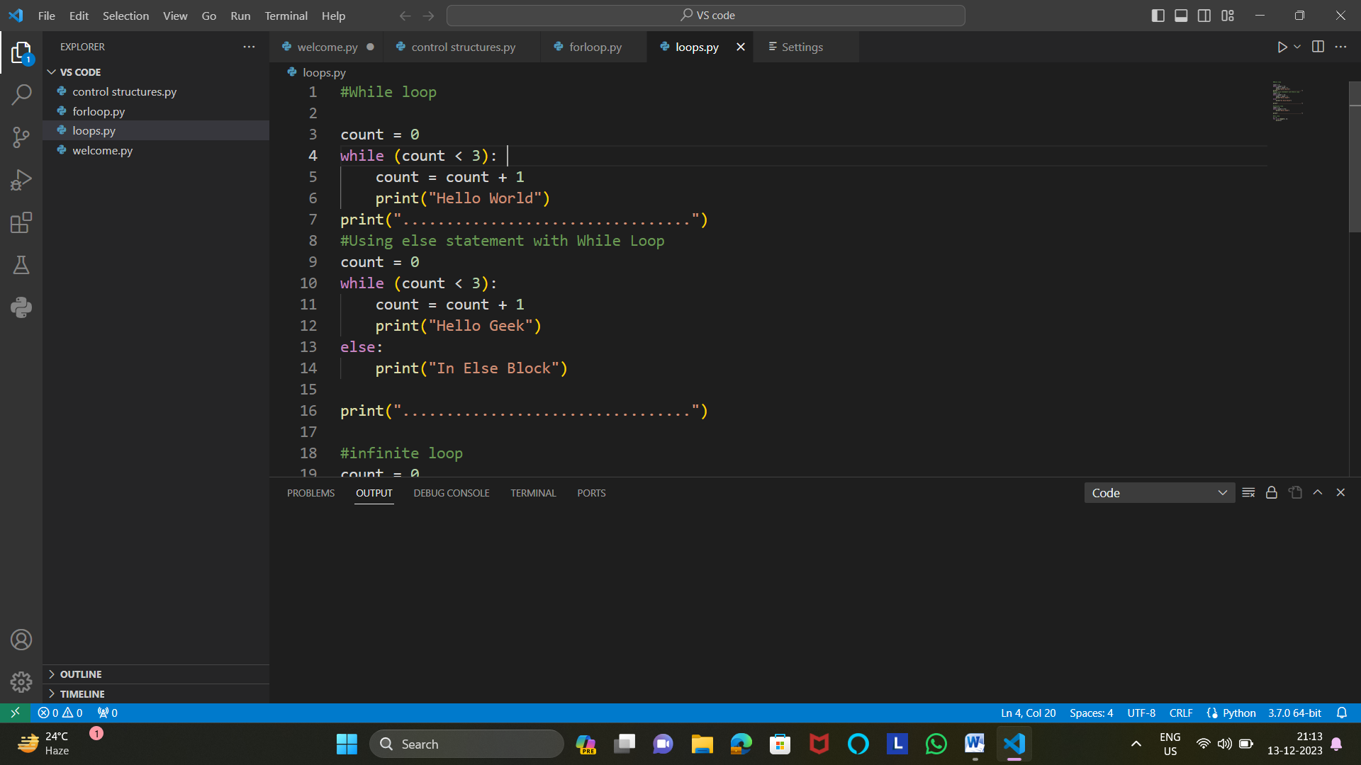

5)infinite loop anf for loop

